**Sexual misconduct is against the policies of the ELCA**

The Alaska Synod of the Evangelical Lutheran Church in America works in cooperation with member congregations to prevent, detect and remedy the effects of sexual misconduct within the Church.

The Alaska Synod is strongly committed to working with Church agencies and local parishes to insure that the Church at every level is free from any form of sexual misbehavior or misconduct. All forms of sexual misbehavior are unacceptable within the Church and are subject to intervention and/or disciplinary action. Such a policy compliments the remedies provided in civil and criminal law for sexual misconduct and harassment.

*Every congregation, every Church should be a safe place where people can worship, learn, work, love, and receive care in a manner that is free from sexual misconduct.*

The Alaska Synod Policy on Sexual Misconduct is available through the Office of the Alaska Synod (elcaalaska@gmail.com) and on our website, elcaalaska.net.

In addition, the Synod encourages every congregation to adopt its own sexual misconduct policy.

**Who can help?**

**Report sexual misconduct by pastors or deacons to a member of the Alaska Synod Response Team**

**Bishop Shelley Wickstrom**

aksynodbishop@gmail.com

1847 W. Northern Lights Blvd. #2

Anchorage, AK 99517

907-272-8899

**The Rev. Rick Cavens**

501 E. Bogard Rd.

Wasilla, AK 99654

907-376-3522

**Ms.** **Elizabeth Kugzruk**

[Ekugzruk\_63@hotmail.com](mailto:Ekugzruk_63@hotmail.com)

Nome, Alaska

907-304-9188

**The Rev. Kaitlin Pabo-Eulberg**

kpaboeulberg@gmail.com

Valdez, AK 99686

970-222-2088

**Ms. Jan Rud** [jan.rud913@gmail.com](mailto:jan.rud913@gmail.com" \t "_blank)

North Pole, AK

808-230-0245

**Mr. Randy Sutak**

[rsutak@gmail.com](mailto:rsutak@gmail.com)

907-957-1294

**Bishop Elizabeth Eaton**

8765 W Higgins Rd

Chicago, IL 60631

1-800-638-3522

**The Alaska Network on Domestic Violence and Sexual Assault**

907.586.3650

www.andvsa.org

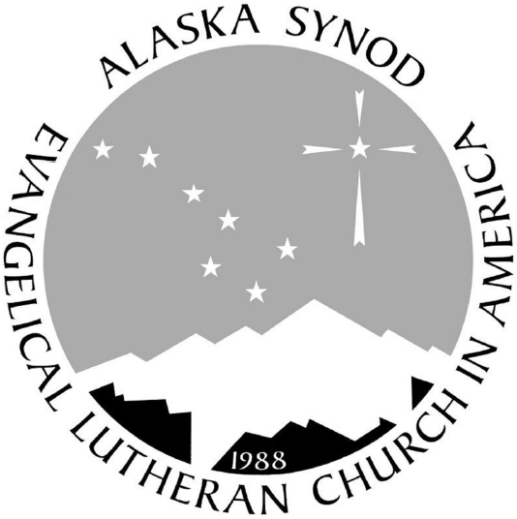

**Keeping**

**The Church a Safe and Sacred Place for All!**

Sexual Misconduct Prevention

***First Response***



**The Church’s Concern**

The Church needs to be a safe place for all.

Every level of the Church and every agency and congregation affiliated with the Church must be free of sexual misconduct. When God’s gift of sexuality is used faithfully, the Church is a safe place for all to worship, learn, work, play, and be helped in a manner that is free from sexual exploitation, abuse, and harassment.

When the Church becomes an unsafe place, the integrity of the Gospel is impaired, particularly among those who are victimized.

Because pastors and deacons (rostered leaders) are in a position of power, they should not violate another person’s spiritual, emotional or physical well-being.

On the contrary, rostered leaders have the responsibility of protecting the boundaries of persons, especially those who are vulnerable. Young people, as well as individuals experiencing life crisis situations like grief, family conflict, or emotional turmoil of marital conflict, separation or divorce, are especially vulnerable to victimization.

**What does sexual misconduct within the Church include?**

* Sexual advance, which may or may not include sexual intercourse
* Requests for sexual favors
* Implied or blatant threats
* Innuendo, humor, and jokes about sex or gender-specific traits
* Suggestive or insulting whistling, gesturing, or leering
* Offensive contact (patting, pinching, brushing against the body), attempted or actual fondling or kissing, or any other form of sexualized behavior, including intercourse
* Requiring submission to sexual conduct or communication in order to obtain the services of the Church, or to be employed there
* Sexual conduct, or communication that interferes with employment or the services received from the Church or those affiliated with the Church
* Other sexual contact or communication that creates an intimidating, hostile, or offensive environment

**Mutual consent**

The belief that there was mutual consent does not exonerate the accused pastor or deacon. Sexual misconduct results when those in positions of authority use that authority to create an intimidating or hostile environment by violating the healthy emotional and relational boundaries that are vital in establishing trust in that relationship. From the perspective of this Synod, there is no mutual consent.

**What can you do?**

If you feel you have been subjected to sexual misconduct with the Church:

* Say no, if you can do safely. Be direct and firm. Tell the person without apology that you want the behavior to stop.
* Keep records of what happened and when. Document dates, times, places, witnesses, and the nature of the misconduct. Save letters, cards, and/or notes.
* Contact Bishop Wickstrom or another member of the Response Team. It takes courage to come forward and report an incident of sexual misconduct. We will make every effort to respond to you with respect and care.

**The Response Team**

Any Response Team member is available to hear a report of Church-related sexual misconduct. They will listen carefully and act expediently on your report. They reflect the Church’s care and concern for you and will begin an immediate response. Specific allegations against a named rostered person will be relayed to the Bishop. The members of the Response Team act as representatives of the Bishop of the Alaska Synod of the ELCA.

**Please remember…**

* Don’t blame yourself.
* Don’t delay. Misconduct may continue if

you delay.

* Don’t keep it to yourself. You will help

yourself and others by speaking out.

* Sexual misconduct is a violation of Church

policy and often violates the law.