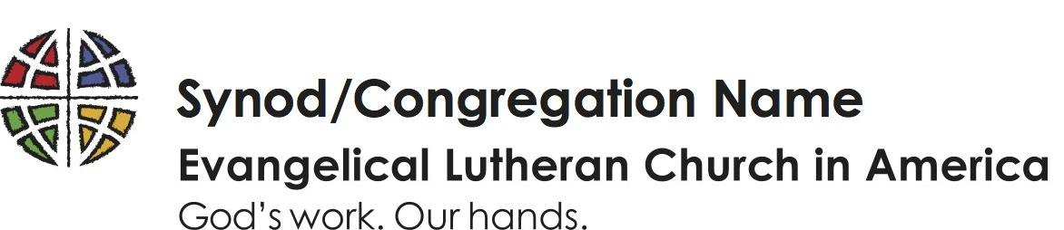
The Alaska Synod of the
Evangelical Lutheran Church in America
God’s Work. Our Hands.
A Resolution of Gratitude to
Christ Lutheran Church

WHEREAS the congregation of Christ Lutheran Church generously offered the use of their facility, staff, and members for the 2020 and 2023 Synod Assembly meetings; and

WHEREAS the Synod Assembly voted to accept such an offering during the 2019 Synod Assembly; and

WHEREAS the Synod Assembly met online for the 2020, 2021, and 2022 assemblies; and

WHEREAS the voting members represent each Evangelical Lutheran Church in America congregation of the Alaska Synod and their respective pastoral and support staff understand and recognize the effort and coordination involved in such a large and complicated undertaking;

THEREFORE BE IT RESOLVED that the congregations of the Alaska Synod of the Evangelical Lutheran Church in America extend their most heartfelt thanks to the staff and members of Christ Lutheran Church for their planning, hard work, enthusiasm, and faithful support of the 2023 Synod Assembly.

Overflow with Hope

