Alaska Synod
Evangelical Lutheran Church in America
God’s work. Our hands.

March 12, 2020

A Letter to the Pastors, Deacons and Congregations of the Alaska Synod

Kin in Christ,

This world that God loves is experiencing a pandemic. Alaska currently has no diagnosed cases of COVID-19 but we will. Maintaining physical distance is an easy way of caring for our neighbor. To do our part in slowing the spread of the virus, the Executive Committee of the Synod Council is re-scheduling the Synod Assembly for October 9-11, 2020 at Christ Lutheran Church in Soldotna. The local planners are ready to pick up the work next fall on our behalf. This is a can-do action that we won’t get a second chance to make.

We anticipate conducting an email vote of those registered as voting members on Saturday, April 25. We are in the process of getting legal advice on how to establish a quorum, receive nominations from “the floor,” and elect nominees whose terms begin July 1. More information will be provided.

The Collegium scheduled to focus on Healthy Boundaries is being re-scheduled for October 6-8 in the Anchorage area. We will share this training with the rostered leaders of the Presbytery of the Yukon.

The flight reservations our office has made to and from Anchorage for the April Assembly and Collegium will be cancelled. Due to the generosity of Alaska Airlines, those tickets will not have change fees for the same passengers next fall.

The Synod Council will meet by ZOOM on March 21. The Seward Peninsula Lutheran Ministries Association officers have cancelled the Spring Conference at Our Savior’s Lutheran Church in Nome this April.

Congregations in hurricane and blizzard areas of the church remind us that being the church is more than gathering for Sunday worship. Congregations in outbreak centers have cancelled worship. If your community experiences an outbreak, you will make a local decision on cancelling worship. Be courageous in not meeting in person. Hold meetings by ZOOM or phone.

Our kin in the Northwest Washington Synod have spent the last two weeks navigating this outbreak. They suggest the following:
- Livestream worship for those not in attendance if you are still gathering in person (how to here)
- Livestream worship with only worship leaders in attendance if you are not gathering in person.
- Pre-record worship and share it on social media, your website and email.
- Lead Bible Study, confirmation classes, and/or conversations via Zoom or Google Hangouts.
- Host a regular conference call (using Zoom, Google Hangouts, etc.) to check in.
- Consider setting a common prayer time, so folks know they are praying together even if they aren’t gathered in person.
- Send out daily devotions via email or text.
- Create and mail a daily devotional for those isolated.
- Create a phone tree for checking in with parishoners who are isolated and/or not connected online.
- Divide up your church membership contact list among other leaders and call everyone to check in.
- Identify folks who need support re: grocery & supplies. Encourage sharing of supplies.
- Send cards to those who are isolated.
- Send notes of thanks and care to people, especially workers on the front lines and local care facilities like nursing homes and hospitals.
- Consider small group (no touch) outdoor gatherings: service projects, hikes, holy play time, wild church, etc.
- For our nursing home/care facilities: offer a daily prayer or devotional time over the intercom system.
- If you are healthy, volunteer with programs that provide critical services and need extra help at this time (ie. feeding programs, shelters, etc.)
- Pay attention to the impact on young children. For ideas on how to respond, see this post from buildfaith.org: https://buildfaith.org/coronavirus-anxiety-children-and-the-church/
- Many of our congregations have contracts with other congregations or groups for the use of the facilities, and we encourage you to be in contact with those organizations to determine the best way to proceed.
The apostle Paul reminds us that nothing can separate us from the love of God in Christ Jesus our Lord. As we all respond to COVID-19, remember that God is faithful, that God’s love is bold, and that God comes to serve and be with all God’s people. Continue in your faithfulness. Be bold in making the good news of Jesus available in new and unexpected ways and seek opportunities to serve those who are in need.

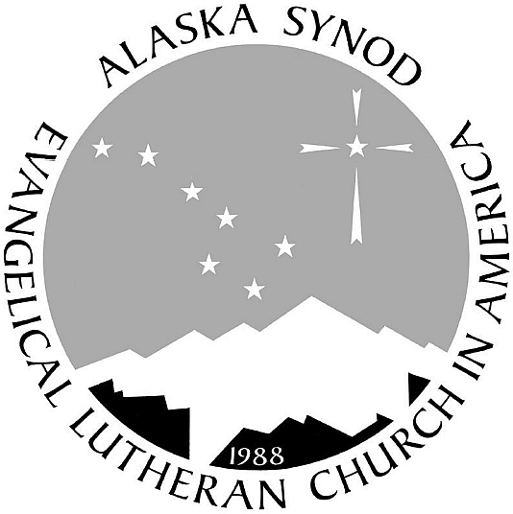
In the stubborn love of Jesus Christ,

Bishop Shelley Wickstrom

