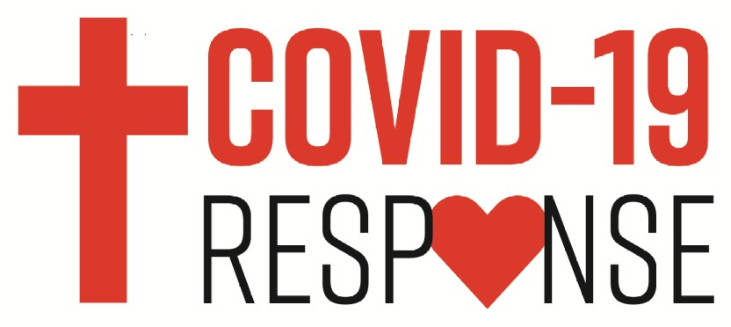

Alaska Synod COVID-19 Relief Fund

Congregation Name

City/Town

Contact person

Email address

Phone number

Mailing address

Amount requested
_________________________________

_________________________________

_________________________________

_________________________________

_________________________________

_________________________________

_________________________________

Application Questions

- How has the COVID-19 pandemic affected your congregation’s financial situation?

2.) Please explain your congregation’s financial need in the next two months, including immediate funding needs.

1

3.) Please list total offerings received (not designated gifts) or program-specific funding for each of the following months.

January 2023 _____________________

February 2023 ___________________

March 2023 _____________________

January 2024 _____________________

February 2024 ___________________

March 2024 _____________________

4.) Has your congregation applied for the federal Payroll Protection Plan (PPP)? Have you been approved? If you have not applied, do you intend to do so?

5.) How have you communicated the financial need to your congregation?

6.) What other sources of funding have you explored?

I certify that I am authorized by the congregational council to apply for this fund.

Signature (may be typed) ________________________________________________

Title ___________________________________ Date ________________________

Date of council vote to apply for Synod COVID-19 relief fund _____________________

Please return the completed application to aksynodbishop@gmail.com You may also print and mail to Alaska Synod, ELCA, 1847 W. Northern Lights Blvd. #2, Anchorage, AK 99517.

2

