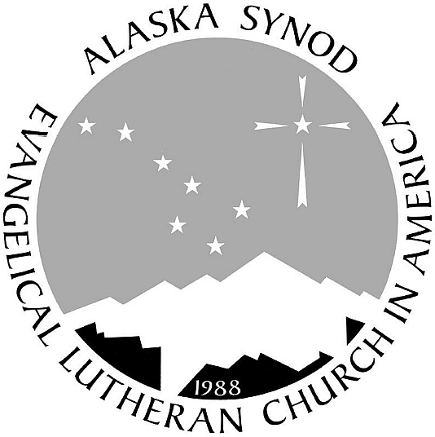
Alaska Synod
Evangelical Lutheran Church in America
God’s work. Our hands.

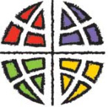

March 16, 2020
Dr. Anne Zink, Chief Medical Officer for the State of Alaska

Judicatory leaders were invited to this teleconference and asked to share this with those in our circles. (The teleconference system cannot accommodate every pastor in the state.)

The corona virus includes the common cold, MERS, SARS,... COVID-19 is called a “novel” virus because it is new which means no one has immunity. Children and young adults often show no signs of which means they can spread it easily. Eighty percent of people who get it will be fine. The rate of how it spreads is still under study. Obviously, the close contact on cruise ships provided the perfect conditions for spreading it. We have plenty of cases where it is not clear how the virus was contacted.

One caller mentioned that the CDC is now recommending gatherings of no more than ten people.
Dr. Zink responded:
“Move to online now. We can socially distance without being socially isolated.”

“We are developing new ways to think about virus transmission. We need to change our social behavior now. “

“A test is not a treatment. A test is time limited. It doesn’t tell us how much virus will be present in a person tomorrow.”

“We are working with two efforts: containing the folks who are symptomatic and mitigating the spread by social isolation.”

“In Alaska, especially, our health system is limited. Our hospital beds are usually at 90% with heart attacks, broken bones and babies being delivered. We need to flatten the rate of infection so our health system is not overwhelmed.”

“Thank you for the ways you are modeling care of neighbor through making sure folks have food, medicine and are not socially isolated.”

Recommended Resources:
Revive Alaska.com Department of Health and Social Services, State of Alaska
CDC Your local department of health.

Folks, this is our opportunity to partner across this state to mitigate the spread of this virus. We can do this! I am asking that you and your council cancel public worship and meetings through the end of March.

This is an opportunity to partner with a neighboring congregation to share online worship like the UMC and Resurrection Lutheran did in Seward. This is a time to learn how to film worship experiences like Christ Lutheran-Soldotna did and that Christ Lutheran-Fairbanks is learning. This is a time to learn from Christ Our Savior and Central Lutheran about their experience in putting their entire services on Facebook Live for years.

Our forebearers in the faith also knew times of contagion. Faith survived. Let’s do our part.

In Christ,
Shelley

